**Angular installation and creating project of Angular info management with firebase**:

1. Install Node.js
2. npm install -g @angular/cli (for installing angular cli)
3. ng new projectname (for creating angular project)
4. ng g c componentname(for creating component)
5. ng g s servicename( for creating service)
6. npm instal --save firebase angularfire2(installing firebase)
7. app-routing.module.ts (which containes all routes in our application)

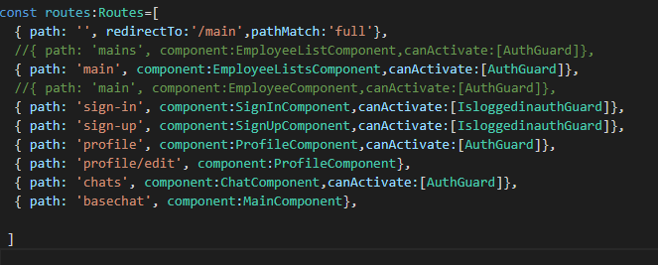

1. update the environment.ts with the key pair from firebase console 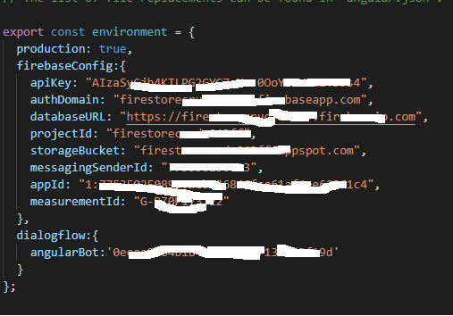
2. update the environment varibale in app-module.ts 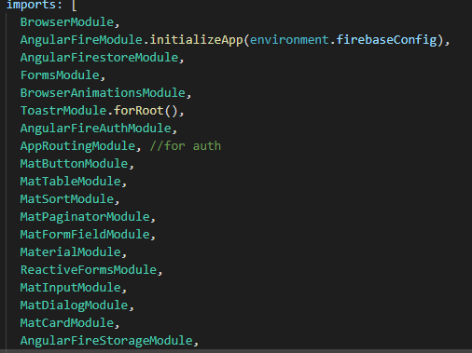
3. update the service components which we create in our project in app-module.ts in provider serction. 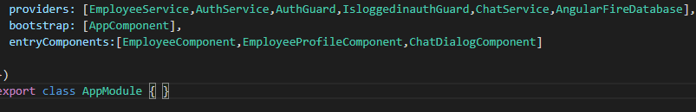
4. The **ng-if Directive** in AngularJS is used to remove or recreate a portion of HTML element based on an expression.

Ex: in the application we used in header.html for all anchor tag, to check if the user is logged in or not, i.e: it the user logged we replace login with logout. 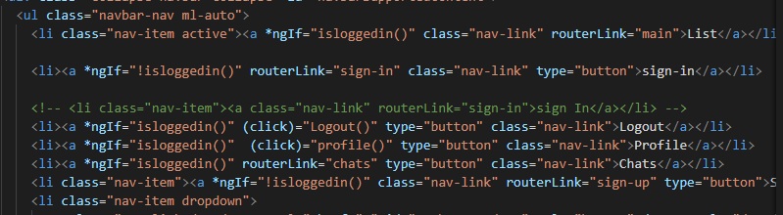

1. How to navigate to another page 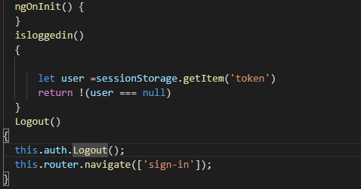
2. Complete sign-in action
3. 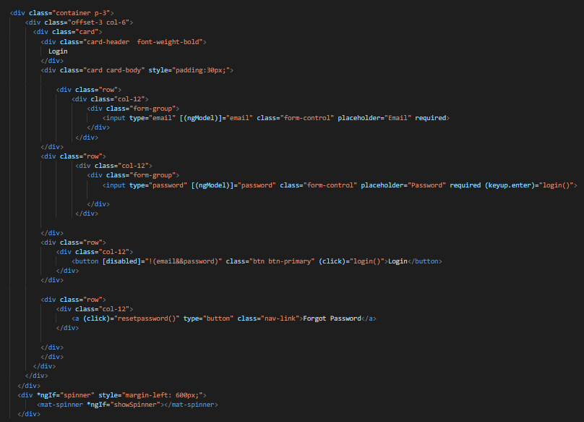Html code
4. And its corresponding typescript code

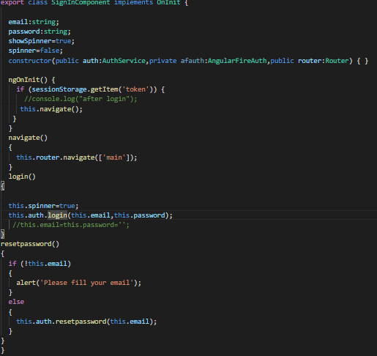

1. How to use toaster in angular
2. npm install ngx-toastr --save
3. npm install @angular/animations --save
4. update in anguar.json
5. "styles": [
6. "node_modules/ngx-toastr/toastr.css",
7. "src/styles.css"
8. ],
9. Import in app.module.ts
10. imports: [
11. BrowserModule,
12. BrowserAnimationsModule,
13. ToastrModule.forRoot()
14. ],

iv) use in any file

this.toastr.success(message, title)

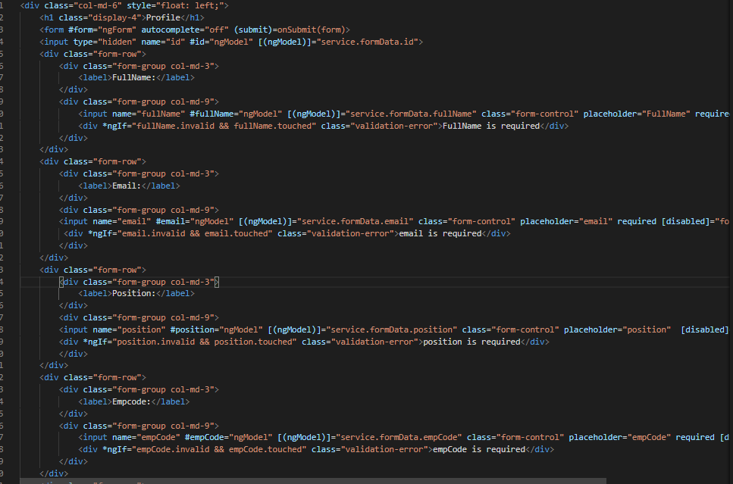15. Angular form:

In ngonit() method fetching the current user details and assigning to formdata, so html will contain all values when page load.

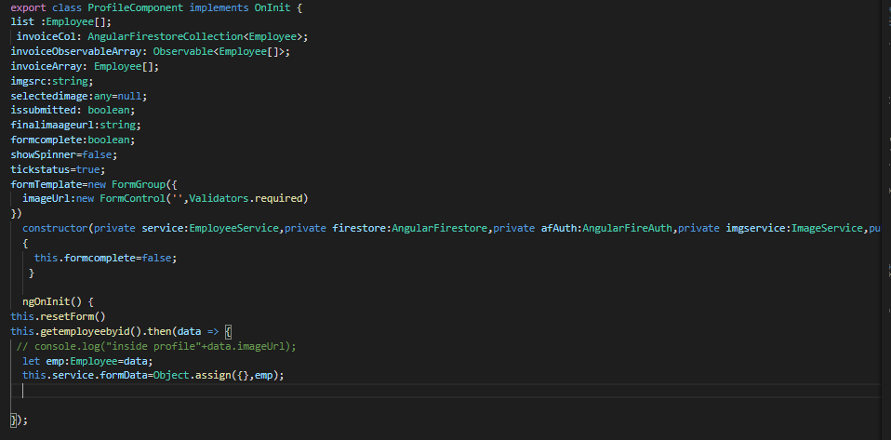

The code to update the details after editing the above 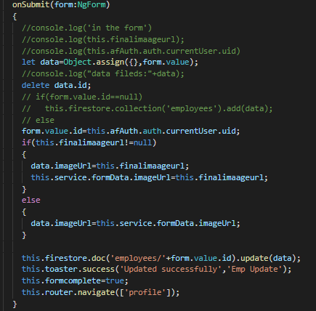

1. Fetching all collections from firestore
2. Calling the method }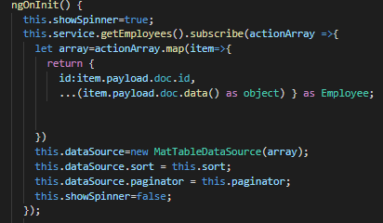
3. In the above method we are calling getEmployees() which is in the service 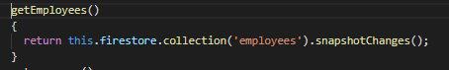
4. Fetching only single document from collection 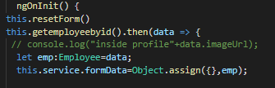

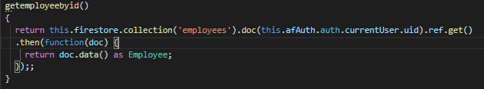

1. How to push the data to firebase realtime database(list) 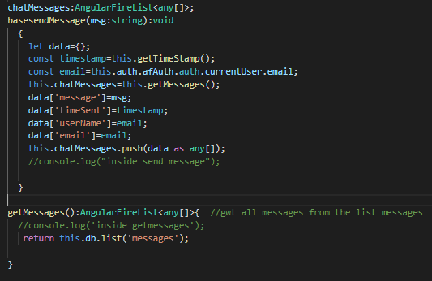
2. How to pass the data from one component to another component
3. Fetch the list of data in one component(feed.ts) 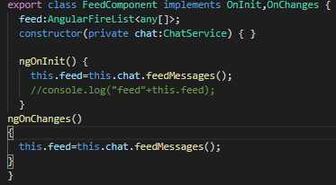
4. feedMessages() method in chatservice.ts

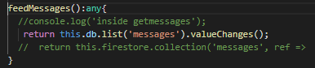

1. sample feed from the list ‘messages’ 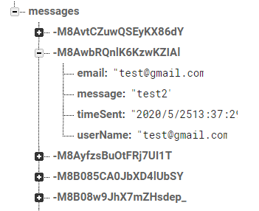
2. passing the every feed using ngFor to another component message.ts 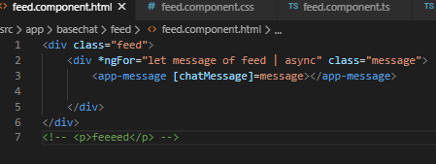
3. how to take the input feed in message.ts which came from feed component 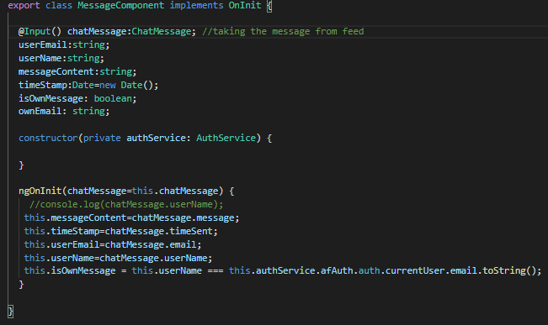
4. how to print in message.html 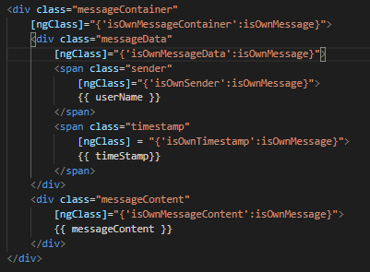
5. how to use authguard in angular
6. create a Authguard class which implements canActivate, canActivate method which is used validate the routing. 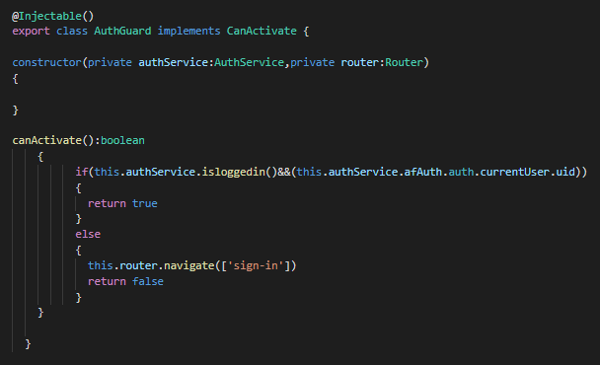
7. write the authguard in the app.module.ts in providers 
8. How to add authguad in routing (app-routing.module.ts) 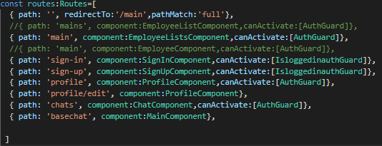
9. How to open entire component(Employee-profile) as dialog box in another component(Enployee-list) when particular emploee row is clicked
10. First add the component(Employeeprofile) in app.module.ts 
11. Add matdialog in the class emploee_list 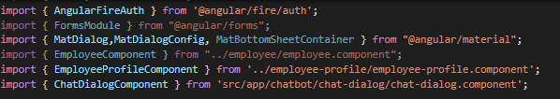
12. Add method to display the component with the values in employee-list 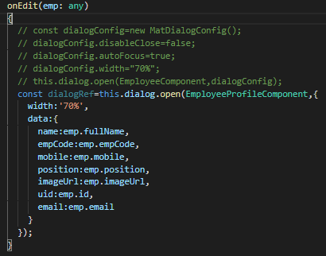

**Angular to call Rest api methods:**

1. In spring-boot create class which is a model 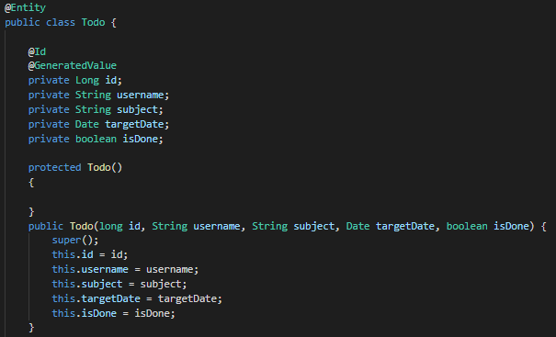
2. restcontroller 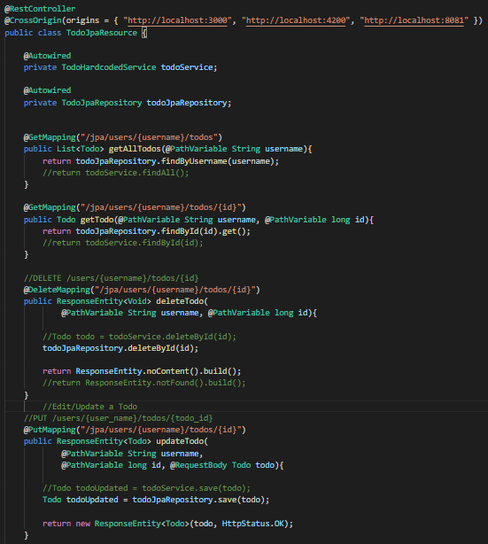 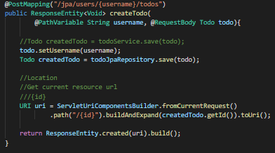
3. List-todos in angular html page 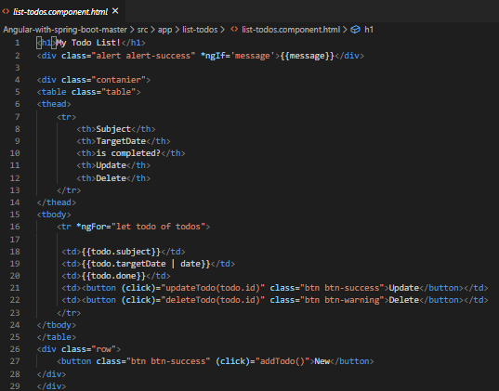
4. 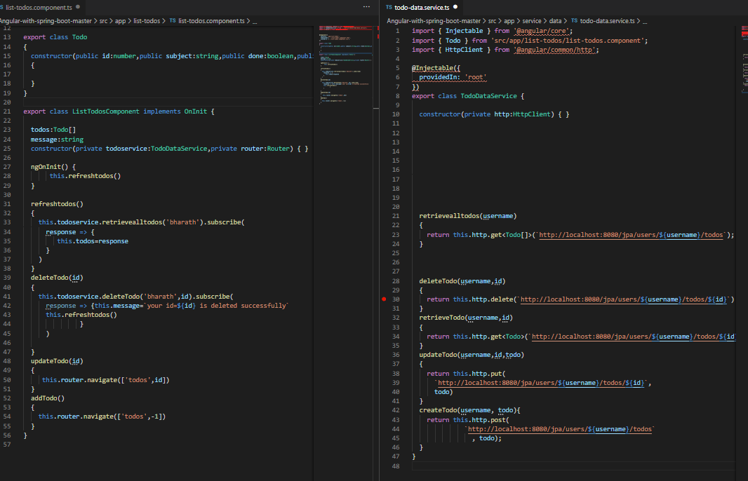List-todos.ts and service files
5. In the above we see only retriveall,delete. For update and delete we need to pass the same data as todo so we navigate to i) this.router.navigate(‘todos’,-1] for adding new todo . ii) this.router.navigte(‘todos’,id] for updating the existing todo

Now below is the todos component where we need to check the parameter in a conditon and do the corresponding action

